**Experiment No.4**

**Aim:** Edit/compile/run a program to read the radius of a circle and print the area of the circle.

**Program A:**

import math as M  
radius = float(input("Please Enter the radius of the given circle: "))  
area_of_the_circle=M.pi*radius*radius  
print("The area of the given circle is: ",area_of_the_circle)

**Output:**

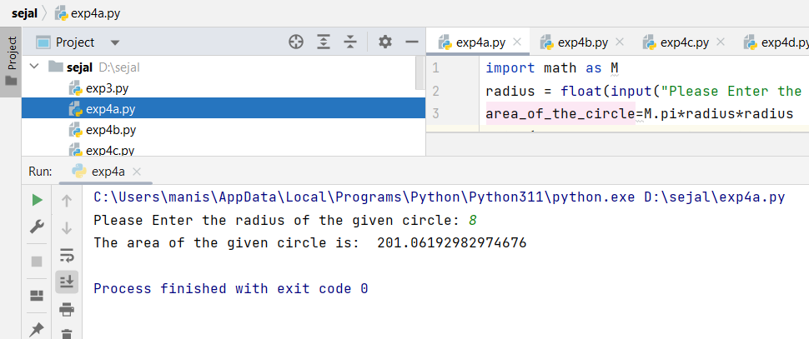

**Program B:**

pi = 3.14  
Radius = float(input("Please enter the radius of the given circle: "))  
area_of_the_circle = pi*Radius*Radius  
print("The area of the given circle is: ",area_of_the_circle)

**Output:**

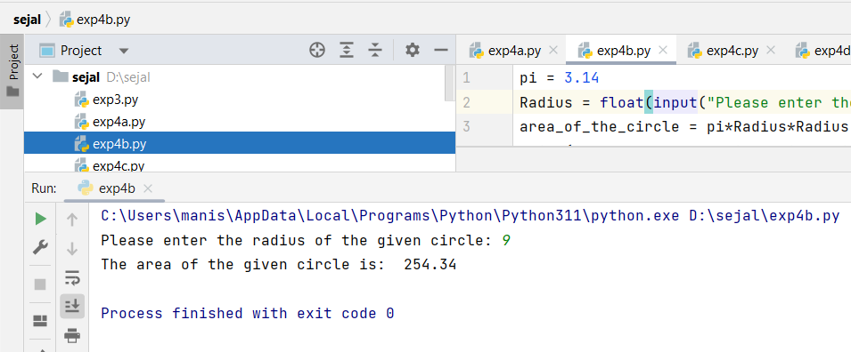

**Program C:**

import math  
  
def area_of_the_circle (radius):  
 area = radius**2*math.pi  
 return area  
radius = float(input("Please enter the radius of the given circle: "))  
print("The area of the given circle is: ",area_of_the_circle(radius))

**Output:**

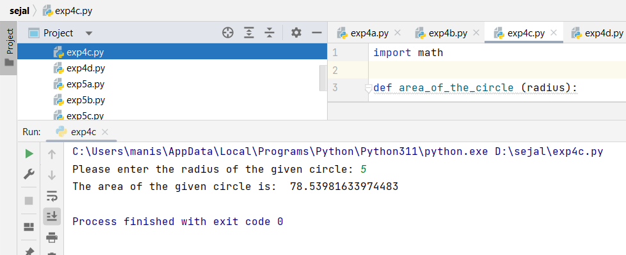

**Program D:** **To find out the area of the Cuboid:-**

length = float(input("Enter the length of the cuboid: "))  
breadth = float(input("Enter the breadth of the cuboid: "))  
height = float(input("Enter the height of the cuboid: "))  
  
area = 2 * (length * breadth + length * height + breadth * height)  
  
print("The area of the cuboid is:", area)

**Output:**

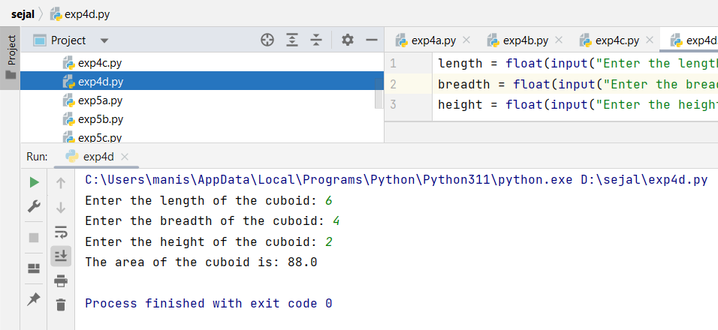

|  |  |  |  |
| --- | --- | --- | --- |
| **Practical Performance**  **(4)** | **Writeup & Oral**  **(4)** | **Attendance**  **(2)** | **Total**  **(10)** |
|  |  |  |  |